**SAHANA L**

**1BM18CS089**

**QUESTION**

Consider the following database for a banking enterprise.

BRANCH (branch-name: String, branch-city: String, assets: real)

ACCOUNTS (accno: int, branch-name: String, balance: real)

DEPOSITOR (customer-name: String, customer-street: String,

customer-city: String)

LOAN (loan-number: int, branch-name: String, amount: real)

BORROWER (customer-name: String, loan-number: int)

i) Create the above tables by properly specifying the primary keys and the foreign keys.

ii) Enter at least five tuples for each relation.

iii) Find all the customers who have at least two accounts at the Main branch.

iv) Find all the customers who have an account at all the branches located in a specific city.

v) Demonstrate how you delete all account tuples at every branch located in a specific city.

vi) Generate suitable reports.

vii) Create suitable front end for querying and displaying the results.

**QUERIES**

CREATE TABLE BRANCH(

BRANCH_NAME VARCHAR2(20), BRANCH_CITY VARCHAR2(20), ASSETS NUMBER(10,2),PRIMARY KEY(BRANCH_NAME));

CREATE TABLE ACCOUNTS(

ACCNO NUMBER(20), BRANCH_NAME VARCHAR2(20), BALANCE NUMBER(10,2),PRIMARY KEY(ACCNO),

FOREIGN KEY(BRANCH_NAME) REFERENCES BRANCH (BRANCH_NAME) ON DELETE CASCADE);

CREATE TABLE DEPOSITOR(

CUSTOMER_NAME VARCHAR2(25), ACCNO NUMBER(20),

FOREIGN KEY(CUSTOMER_NAME) REFERENCES CUSTOMER (CUSTOMER_NAME) ON DELETE CASCADE,

FOREIGN KEY(ACCNO) REFERENCES ACCOUNTS (ACCNO) ON DELETE CASCADE);

CREATE TABLE CUSTOMER(

CUSTOMER_NAME VARCHAR2(25), CUSTOMER_STREET VARCHAR2(25), CUSTOMER_CITY VARCHAR2(25),PRIMARY KEY(CUSTOMER_NAME));

CREATE TABLE LOAN(

LOAN_NUMBER NUMBER(10), BRANCH_NAME VARCHAR2(25), AMOUNT NUMBER(10,2),PRIMARY KEY(LOAN_NUMBER),

FOREIGN KEY(BRANCH_NAME) REFERENCES BRANCH (BRANCH_NAME) ON DELETE CASCADE);

CREATE TABLE BORROWER(

CUSTOMER_NAME VARCHAR2(25), LOAN_NUMBER NUMBER(10),

FOREIGN KEY(CUSTOMER_NAME) REFERENCES CUSTOMER (CUSTOMER_NAME) ON DELETE CASCADE,

FOREIGN KEY(LOAN_NUMBER) REFERENCES LOAN (LOAN_NUMBER) ON DELETE CASCADE);

INSERT INTO BRANCH VALUES('&BRANCH_NAME','&BRANCH_CITY',&ASSETS);

SELECT * FROM BRANCH;

INSERT INTO ACCOUNTS VALUES(&ACCNO,'&BRANCH_NAME',&BALANCE);

SELECT * FROM ACCOUNTS;

INSERT INTO CUSTOMER VALUES('&CUSTOMER_NAME','&CUSTOMER_STREET','&CITY');

SELECT * FROM CUSTOMER;

INSERT INTO DEPOSITOR VALUES('&CUSTOMER_NAME',&ACCNO);

SELECT * FROM DEPOSITOR;

INSERT INTO LOAN VALUES(&LOAN_NUMBER,'&BRANCH_NAME',&AMOUNT);

SELECT * FROM LOAN;

INSERT INTO BORROWER VALUES('&CUSTOMERNAME',&LOAN_NUMBER);

SELECT * FROM BORROWER;

**OUTPUT**

1. **BRANCH**

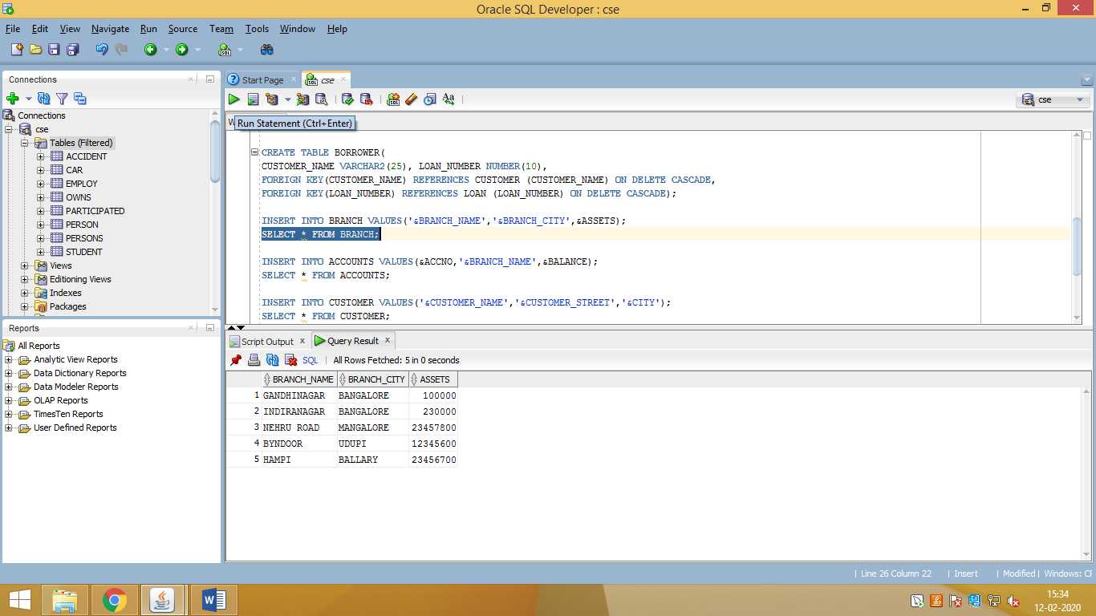

1. **ACCOUNT**

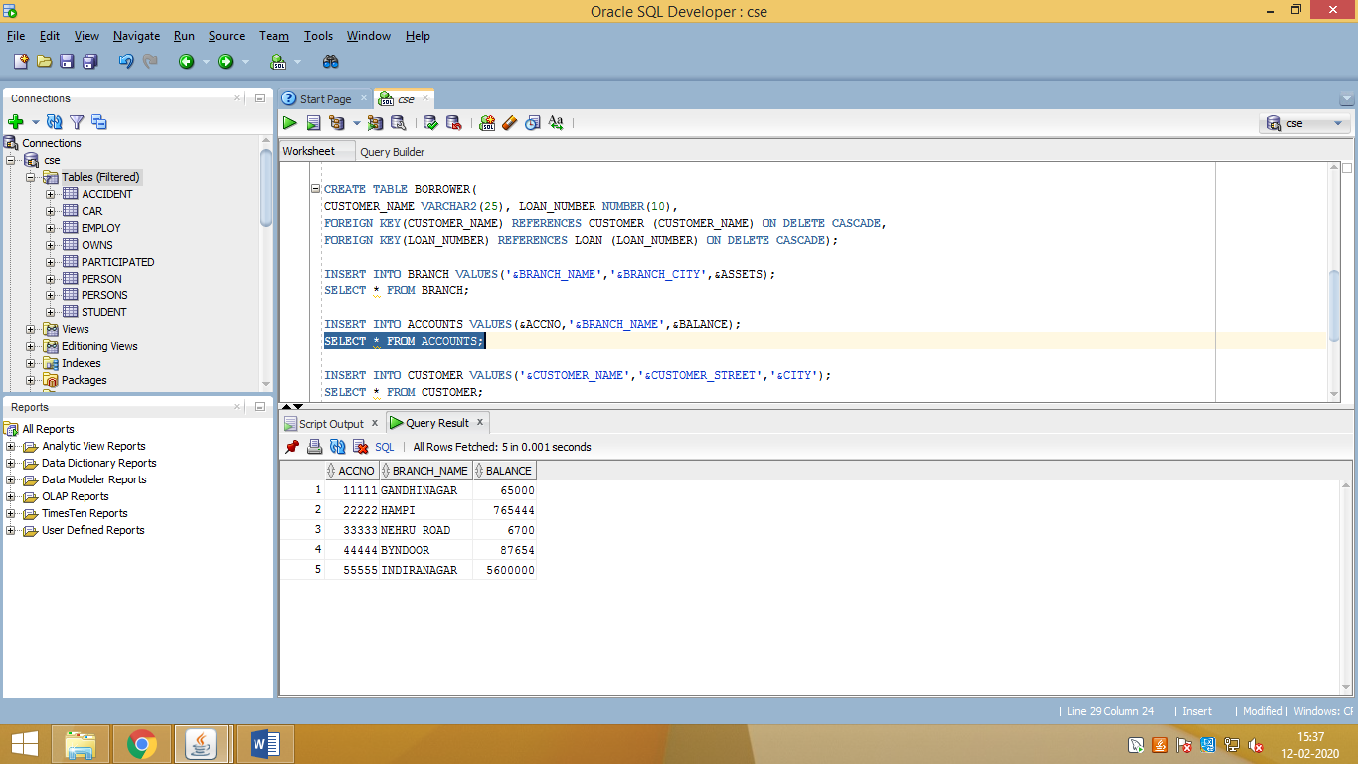

1. **CUSTOMER**

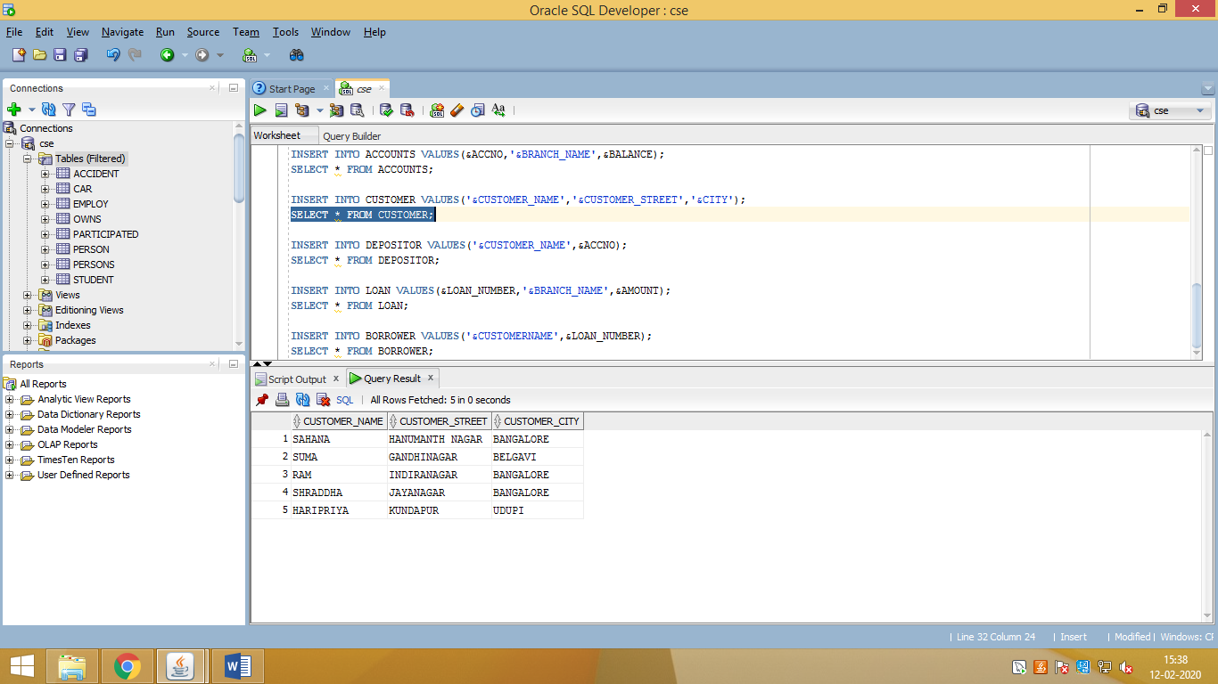

1. **DEPOSITOR**

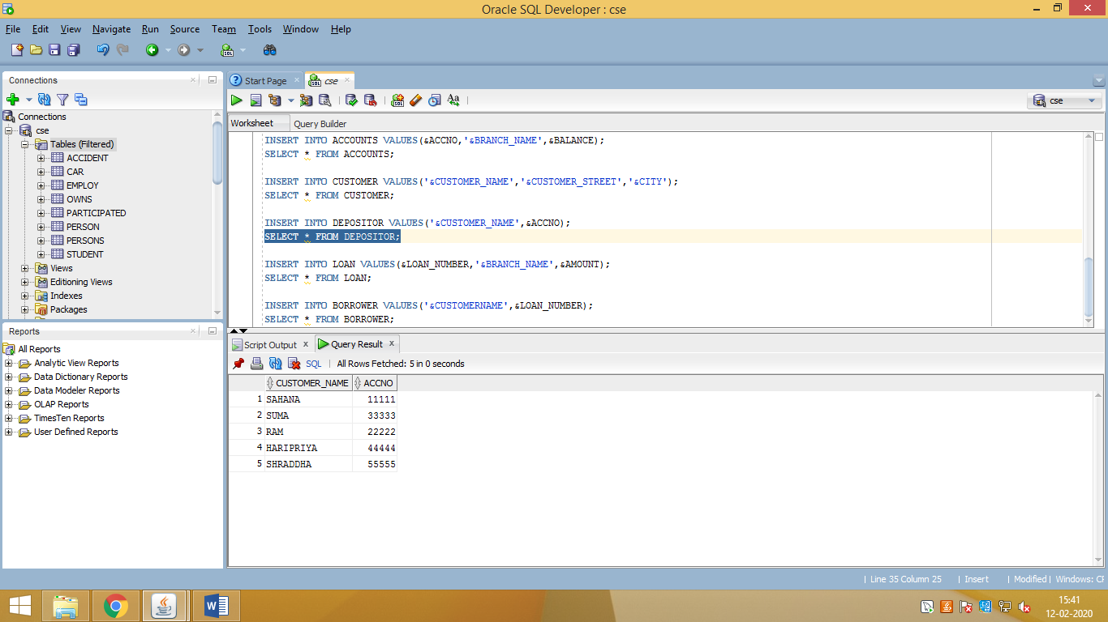

1. **LOAN**

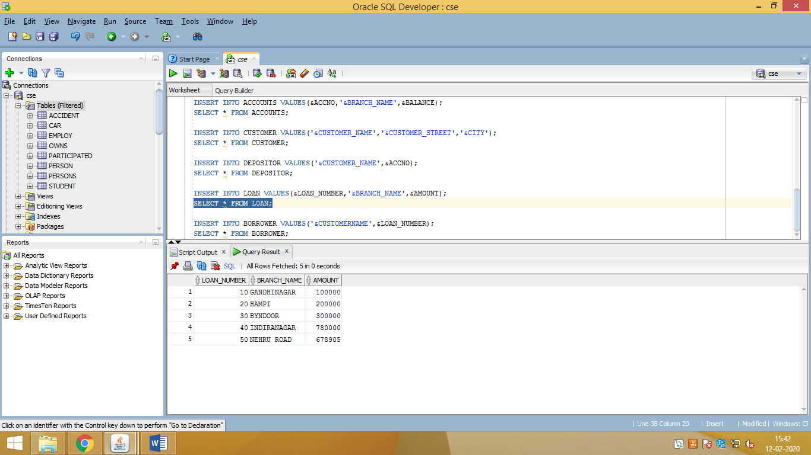

1. **BORROWER**

